CORE JAVA PROJECT
GYM MANAGEMENT SYSTEM
MASTER OF COMPUTER APPLICATION
(MCA)
by
Bala Krishna Chennaiah
(Regd. No: 2024016258)

Under the esteemed guidance of
Dr.Santosh Kumar Uppada
Assistant Professor

DEPARTMENT OF COMPUTER SCIENCE
GITAM INSTITUTE OF SCIENCE
GITAM (Deemed to be University)
VISAKHAPATNAM – 530045, A.P
(2024-2026)

Project Report: Gym Management System

Objective:
The primary goal of the Gym Management System is to manage gym operations efficiently through a console-based Java application. This includes functionalities like member and trainer registration, payment handling, and membership status management.

Technologies Used:
- Language: Java

Concepts Implemented:
- Object-Oriented Programming (Inheritance, Abstraction, Interfaces, Exception Handling)

- Arrays for data storage

- User interaction via Scanner

- Custom Exception (InvalidOperationException)

Key Classes & Interfaces:

- Person (Abstract Class):
- Base class for Member and Trainer
- Contains common attributes (id, name) and an abstract method greet()

- Displayable (Interface):
Contains displayInfo() method implemented by Member and Trainer for polymorphic behavior.

- Member (Extends Person, Implements Displayable):
Stores member details, activation status, and fee info based on membership type.

- Trainer (Extends Person, Implements Displayable):
Holds trainer-specific info like specialization.

- Payment:
Processes and logs member payments.
- InvalidOperationException:
Custom exception to handle invalid operations gracefully.

Main Functionalities:

- Register Member: Adds a new member with unique ID and type (Basic/Premium).

- View Members: Displays all registered members.

- Add/View Trainer: Similar functionality for gym trainers.

- Make Payment: Computes and processes payments based on membership type.

- Deactivate/Activate Member: Toggles membership status with validation.

- Exit: Cleanly terminates the application.

CODE:
import java.util.Scanner;

interface Displayable {
void displayInfo();
}

abstract class Person {
protected int id;
protected String name;

public Person(int id, String name) {
this.id = id;
this.name = name;
}

public abstract void greet();
}

class InvalidOperationException extends Exception {
public InvalidOperationException(String msg) {
super(msg);
}
}

class Member extends Person implements Displayable {
private String membershipType;
private boolean active;

public Member(int id, String name, String membershipType) {
super(id, name);
this.membershipType = membershipType;
this.active = true;
}

public int getId() {
return id;
}

public boolean isActive() {
return active;
}

public void deactivate() {
active = false;
}

public void activate() {
active = true;
}

public double getFee() {
return membershipType.equalsIgnoreCase("Premium") ? 1000.0 : 500.0;
}

public void displayInfo() {
System.out.println("Member ID: " + id + " | Name: " + name + " | Type: " + membershipType + " | Active: " + active);
}

public void greet() {
System.out.println("Hi " + name + ", welcome to the gym!");
}
}

class Trainer extends Person implements Displayable {
private String specialization;

public Trainer(int id, String name, String specialization) {
super(id, name);
this.specialization = specialization;
}

public void displayInfo() {
System.out.println("Trainer ID: " + id + " | Name: " + name + " | Specialization: " + specialization);
}

public void greet() {
System.out.println("Trainer " + name + " here, ready to help you!");
}
}

class Payment {
private Member member;
private double amount;
private String method;

public Payment(Member member, double amount, String method) {
this.member = member;
this.amount = amount;
this.method = method;
}

public void process() {
System.out.println("Processing payment...");
System.out.println("Payment of Rs" + amount + " via " + method + " completed for Member ID: " + member.getId());
}
}

public class GymManagementSystem {
static final int MAX_MEMBERS = 100;
static final int MAX_TRAINERS = 50;
static Member[] members = new Member[MAX_MEMBERS];
static Trainer[] trainers = new Trainer[MAX_TRAINERS];
static int memberCount = 0;
static int trainerCount = 0;
static int memberIdGen = 1001;
static int trainerIdGen = 2001;
static Scanner sc = new Scanner(System.in);

public static void main(String[] args) {
while (true) {
System.out.println("\n--- Gym Management Menu ---");
System.out.println("1. Register Member");
System.out.println("2. View Members");
System.out.println("3. Add Trainer");
System.out.println("4. View Trainers");
System.out.println("5. Make Payment");
System.out.println("6. Deactivate Member");
System.out.println("7. Activate Member");
System.out.println("8. Exit");
System.out.print("Choice: ");

try {
int choice = Integer.parseInt(sc.nextLine());

switch (choice) {
case 1:
registerMember();
break;
case 2:
viewMembers();
break;
case 3:
addTrainer();
break;
case 4:
viewTrainers();
break;
case 5:
makePayment();
break;
case 6:
deactivateMember();
break;
case 7:
activateMember();
break;
case 8:
System.out.println("Thanks for using the system!");
return;
default:
System.out.println("Invalid option. Try again.");
}
} catch (NumberFormatException e) {
System.out.println("Enter a number only!");
} catch (InvalidOperationException e) {
System.out.println("Error: " + e.getMessage());
}
}
}

private static void registerMember() {
if (memberCount >= MAX_MEMBERS) {
System.out.println("Can't register more members.");
return;
}

System.out.print("Enter member name: ");
String name = sc.nextLine();

System.out.print("Membership Type (Basic/Premium): ");
String type = sc.nextLine();

Member m = new Member(memberIdGen++, name, type);
members[memberCount++] = m;
m.greet();
System.out.println("Member added.");
}

private static void viewMembers() {
if (memberCount == 0) {
System.out.println("No members yet.");
return;
}

for (int i = 0; i < memberCount; i++) {
members[i].displayInfo();
}
}

private static void addTrainer() {
if (trainerCount >= MAX_TRAINERS) {
System.out.println("Can't add more trainers.");
return;
}

System.out.print("Trainer name: ");
String name = sc.nextLine();

System.out.print("Specialization: ");
String spec = sc.nextLine();

Trainer t = new Trainer(trainerIdGen++, name, spec);
trainers[trainerCount++] = t;
t.greet();
System.out.println("Trainer added.");
}

private static void viewTrainers() {
if (trainerCount == 0) {
System.out.println("No trainers added yet.");
return;
}

for (int i = 0; i < trainerCount; i++) {
trainers[i].displayInfo();
}
}

private static void makePayment() throws InvalidOperationException {
if (memberCount == 0) {
throw new InvalidOperationException("No members registered.");
}

System.out.print("Enter Member ID: ");
int id = Integer.parseInt(sc.nextLine());

Member m = findMemberById(id);
if (m == null) {
throw new InvalidOperationException("Member not found.");
}

if (!m.isActive()) {
throw new InvalidOperationException("Member is inactive.");
}

double fee = m.getFee();

System.out.print("Payment Method (Cash/UPI/Card): ");
String method = sc.nextLine();

Payment p = new Payment(m, fee, method);
p.process();
}

private static void deactivateMember() {
System.out.print("Enter Member ID to deactivate: ");
int id = Integer.parseInt(sc.nextLine());

Member m = findMemberById(id);
if (m == null) {
System.out.println("No such member.");
return;
}

m.deactivate();
System.out.println("Member deactivated.");
}

private static void activateMember() {
System.out.print("Enter Member ID to activate: ");
int id = Integer.parseInt(sc.nextLine());

Member m = findMemberById(id);
if (m == null) {
System.out.println("No such member.");
return;
}

if (m.isActive()) {
System.out.println("Member is already active.");
return;
}

m.activate();
System.out.println("Member activated successfully.");
}

private static Member findMemberById(int id) {
for (int i = 0; i < memberCount; i++) {
if (members[i].getId() == id) return members[i];
}
return null;
}
}

OUTPUT:

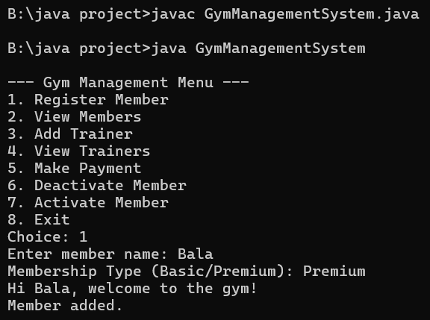

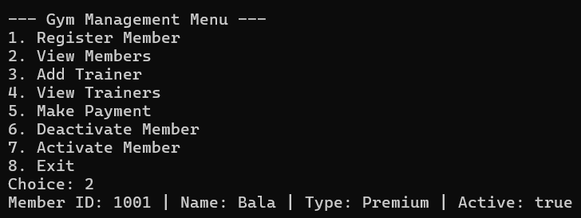
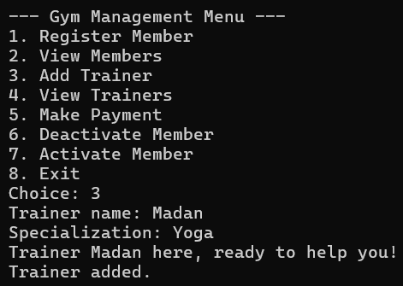

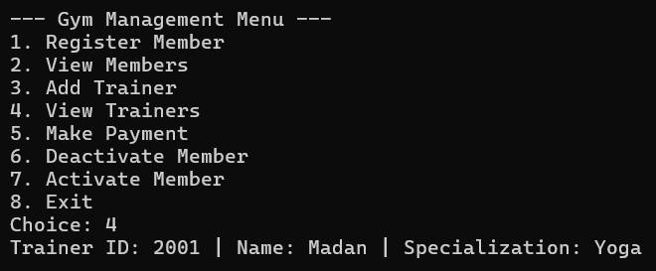

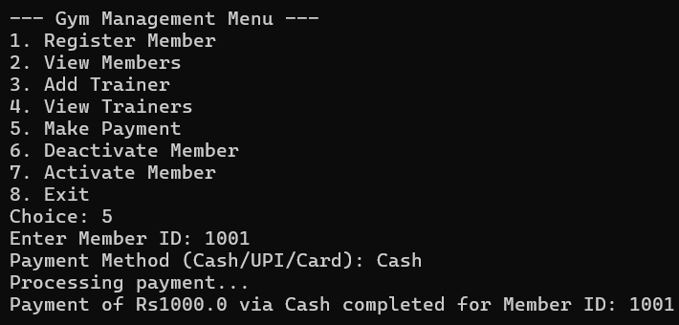
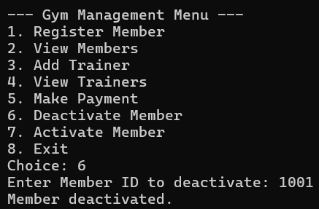

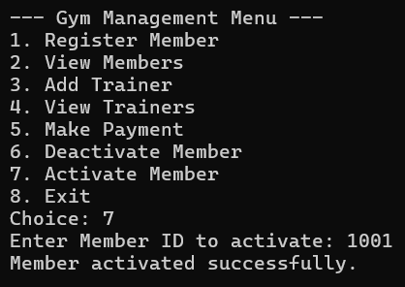

INFERENCE:
The given code implements a basic gym management system using Object-Oriented Programming (OOP) principles in Java, along with exception handling, interfaces, and abstract classes. It allows the management of gym members and trainers, including their registration, payments, activation/deactivation, and information display.

